<Project Title>

(Project Proposal)

Project Code
<Project code assigned by the Project Office>

Project Advisor
<Name of the project internal advisor> (internal)
<Name of the project external advisor (if any)> (external)

Project Manager
<Name of the project manager>

Project Team

Ahmad Sajjad BCSF18E044 Team Lead
Muhammad Ahmad BCSF18E026 Team Member
Masum Muhammad Ali BSCS-F17-51 Team Member

Submission Date
<Provide the date when the proposal is submitted>
Table of Contents
1. Abstract 3
2. Background and Justification 3
3. Project Methodology 3
4. Project Scope 3
5. High level Project Plan 3
6. References 3

Abstract
Smart car parking project aims at providing a confusion free and easy parking. This project helps the drivers of the cars to park their vehicles with minimum wastage of time with accurate information of the availability of the space to park It includes an Arduino Uno as the microcontroller unit to which the servo motors, LCD display ultrasonic sensors (HC-05) are interfaced. The LCD displays the availability of the space, the ultrasonic sensors keeps the check of the number of cars entering and exiting the parking space. The ultrasonic sensors detect the availability of the parking space.

Background and Justification
An automated car parking system is a process through which car parking can be done more efficiently and easily than manual method. The system will provide the user better services. The system counts the number of cars in the garage and checks if there’s any vacancy. There’s an entry and exit path. When vehicle enters, the display shows the number of cars inside. When any vehicle leaves, the count decreases and shown on display. If the garage is full. The display will show a message regarding that. This whole process includes the use of Arduino, Display and sonar. The sonar detects whether the vehicle is entering or leaving. The report then showed on display.

Project Methodology

Hardware Design
- Arduino UNO
- Ultrasonic Sensor
- LCD Screen
- Bread Board
- Power Supply
- Connecting Wires

Flow Chart

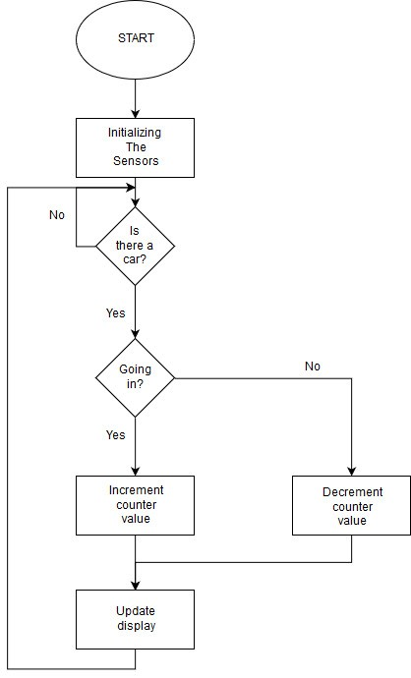

Project Scope
A successful implementation of this project would result in less traffic and chaos in crowded parking spaces like malls and business buildings where many people share a parking area. The automated parking fee system would allow people to travel without cash. It provides drivers with Also, as it would reduce the waiting time, long queues, tension, stress and increase the efficiency of the parking system. As the Smart Car Parking System Requires minimal manpower, there are minimum chances for human errors, increased security in addition to a swift and friendly car parking experience for drivers.

High level Project Plan
This section should contain a high level project plan with important milestones and their submission dates. It should contain:
- High level activities for the proposed system
- Time allocated to each activity
- Resources that will be assigned to complete each activity

References
- The section should contain references of books, journals, magazines and websites consulted for the proposed work.
- You may provide the names of the people and their contact information that you have
consulted.

